# Power Bi Challenges:

## Q1 [Easy] - Find the right relationship

**Tags**: Relationship

#### Department can have multiple employees but employees can belong to only one department. So the relationship between the “Employees” and the “Department” table will be_________________

## Q2 [Medium] - Which JOIN is most suitable?

**Tags**: JOIN

For the tables visualized below, which kind of join will lead to the resultant table?

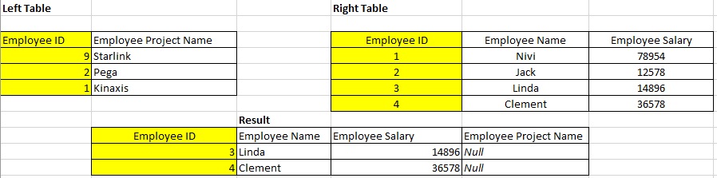

## Q3 [Hard] - Based on Instruction #1 to #5

**Tags**: Data Transformation, Data Modeling, Slicer, Filter, Data Visualization, DAX

Refer to #Instruction Guide business case study to solve the rest of the questions.

Blu wants to analyze the transactions that have gross that are not negative. Further analysis is needed on a Deputy Manager level.

For a Deputy Managers named **Andrew Ma** and **Carlos Grilo,** what is the total sales in Millions?

## Q4 [Hard] - Based on Instruction #1 to #5

**Tags**: Data Transformation, Data Modeling, Slicer, Filter, Data Visualization, DAX

Blu management is interested to know the highest total sales contribution in the top territory made by DMs **Andrew Ma** and **Carlos Grilo** jointly. What is the right answer?

## Q5 [Medium] - Based on Instruction #6 to #7

**Tags**: Data Visualization, DAX, Data Formatting

To analyze the effect of probable loss of gross margins due to un-optimized inventory levels, Blue wants to know if there’s an immense need to maintain higher levels of Inventory. Maintaining higher levels of inventory can pose a serious risk to business due to piling up of unused stocks.

In the process, Management wants to know that out of total sales availed, what percentage sale is due to the **second highest territory** sum of sales. Also to make the inventory more robust, Management wants to target the strong zone for this territory. For which territory the sales are the second highest? Also Find the percentage contribution in sales due to this territory with respect to total sales. Analyze the highest sales year for this territory along with the strongest Non-Zero Quarter in it.

## Q6 [Easy] - After making the final dashboard

For the period years lower than 2011 during which stores have been opened, find out at which time (year, quarter, month) highest rent was generated and how much?

(Note - You’ve consider only the quarter and months which are in the year having the lowest rent and having atleast value greater than 0)

## Q7 [Easy] - After making the final dashboard

The global business head is always on the lookout to expand the business to various new industries in existing regions where penetration is low.

For territories TN,OH, MD, DE and GA, what is the total number of units sold and out of it, much is the units sold for the Shoes category ?